AIIMS Bilaspur observed ‘World Antimicrobial resistance Awareness Week’ (WAAW) 2025 with a series of activities aimed at strengthening awareness towards the global threat of Antimicrobial Resistance (AMR). The fortnight long activities were designed to promote rational antibiotic use and reinforce the Antimicrobial Stewardship Program (AMSP).
Observance of WAAW commenced with a series of interactive sessions with doctors and other health care professionals from different clinical departments. Various pre-analytical, analytical and post analytical challenges and possible solutions were deliberated for improving and providing quality reports for further improving the patient care. Various new test parameter required by different departments pertaining to Microbiology were also discussed. Other major events held during two-weeks long program included quiz and debate competitions for MBBS and paramedical students and e-poster and slogan competitions involving faculty and students. Active participation of healthcare professionals, students, and staff played a key role in the success of WAAW observance in the institute. Their active engagement in activities proved their commitment towards combating antibiotic resistance and promoting the responsible use of antibiotics.
Institutional WAAW celebrations concluded with a valedictory function on 25th November with the esteemed presence of Lt Gen (Dr.) Daljeet Singh (Executive Director), Dr Rupali Parlewar (Dean Academics) and Dr Yatiraj Singi (Officiating Medical Superintendent). During this event various faculty from different departments (Dr Tarun Sharma from General Medicine, Dr Ashok Dubey from Pharmacology, Dr Nalini A from Neonatology, Dr Ranjit Choudhary from Orthopedics, Dr Ajay Dhiman from Surgery, Dr Priti Agarwal from Microbiology) shared their experiences on the rational use of antimicrobials. The event also included the prize distribution ceremony for students and faculty who had participated in quiz, debate, e-posters and e-slogan competitions.
An outreach session, as a part of WAAW celebration, was also conducted at CHC Markand on 27th November 2025, addressing the staff on the need of optimization of antibiotic use among patients attending OPD.

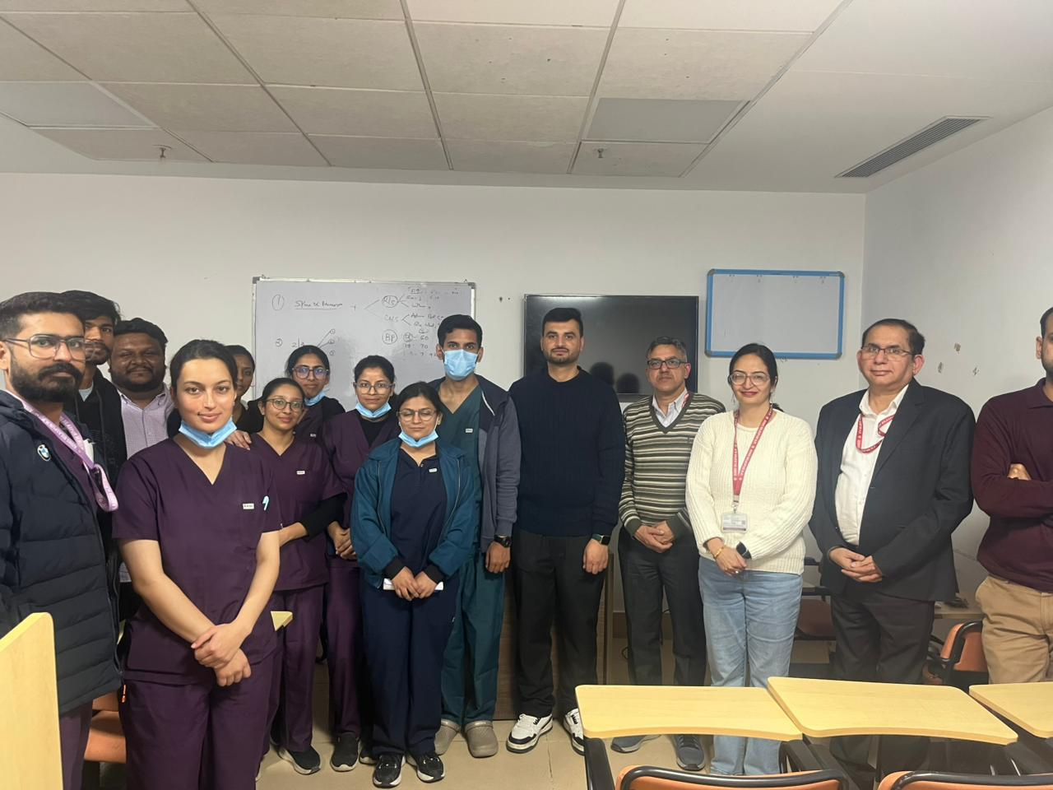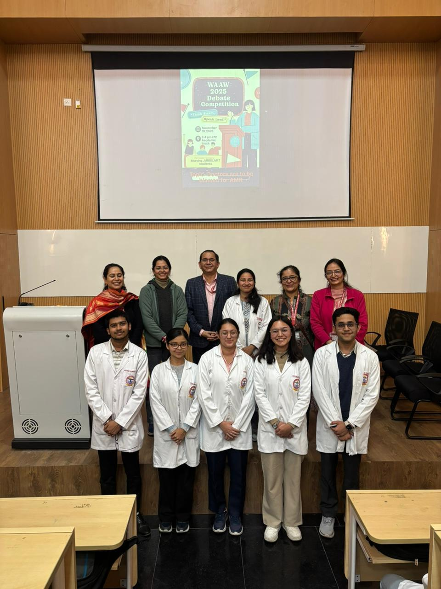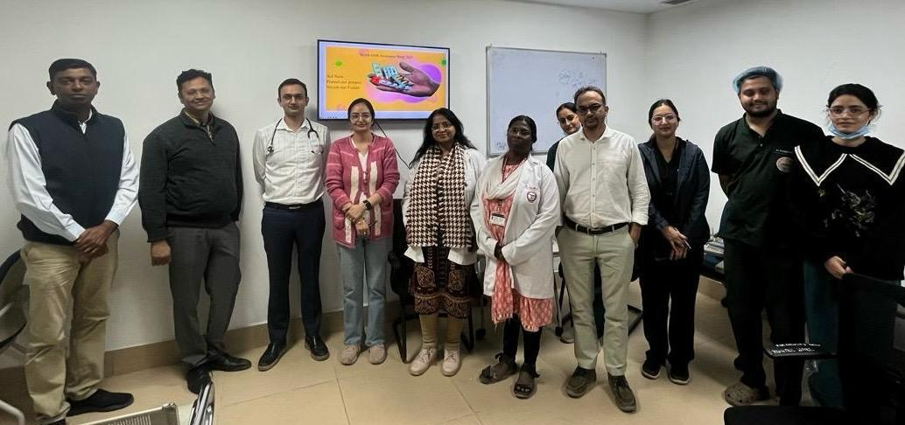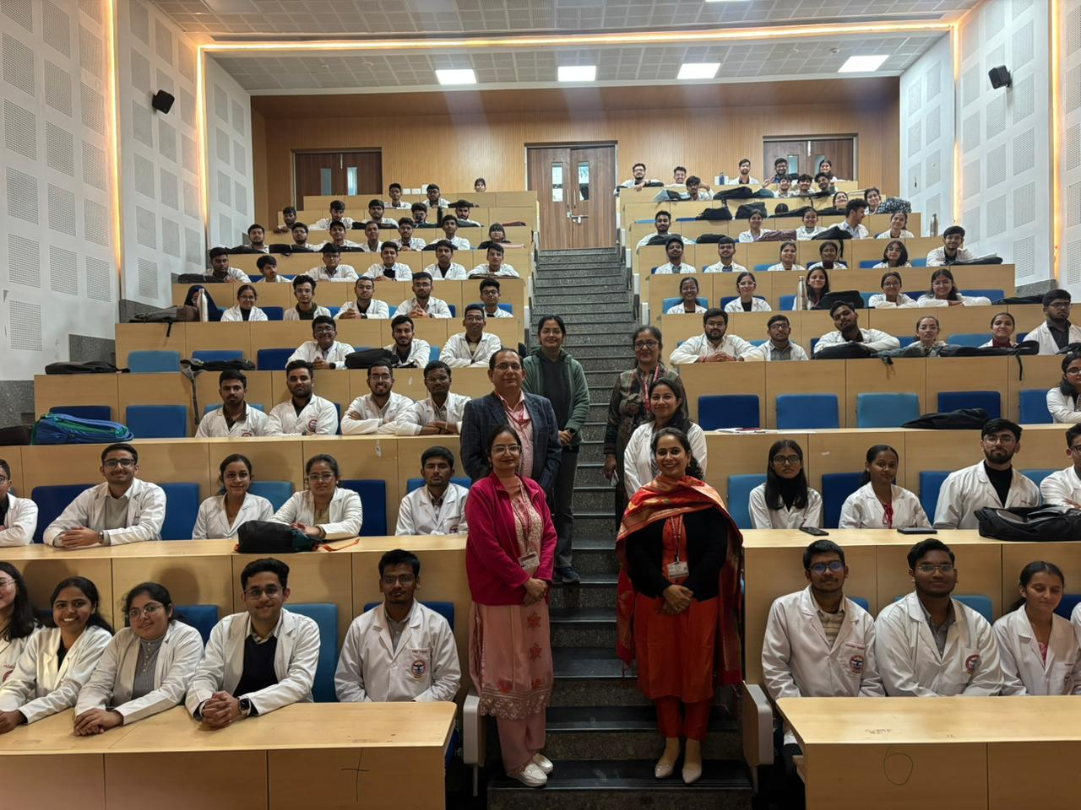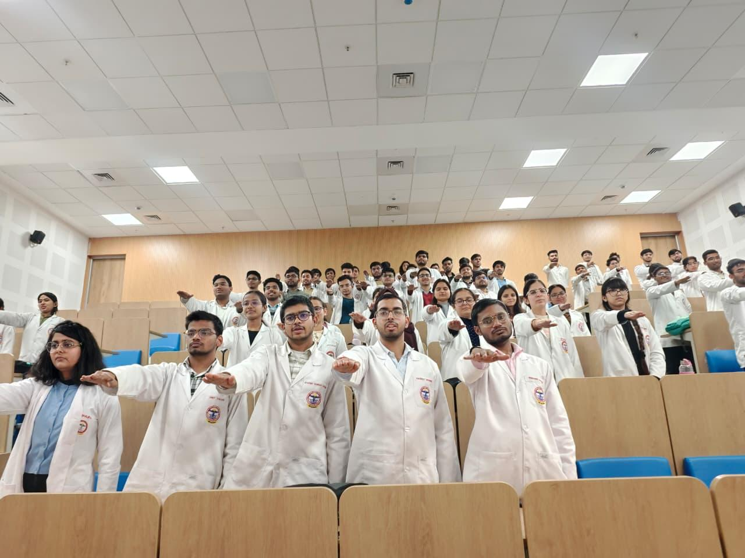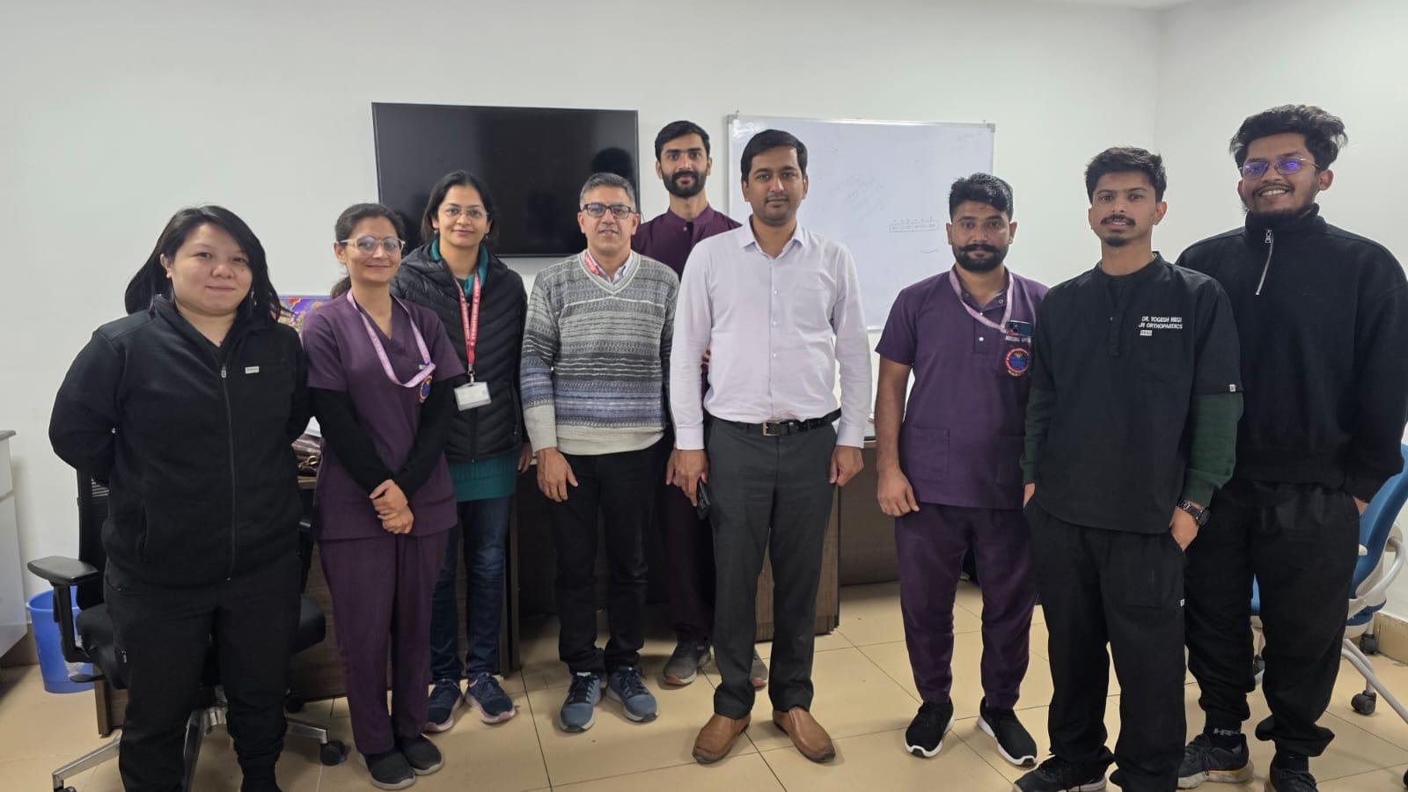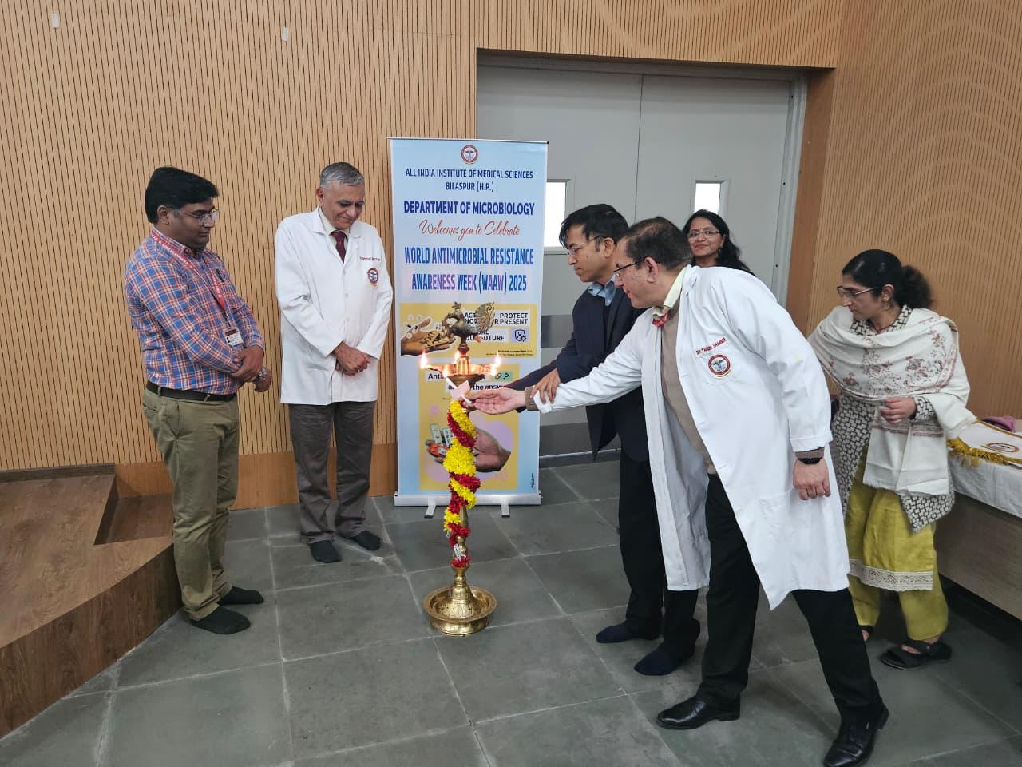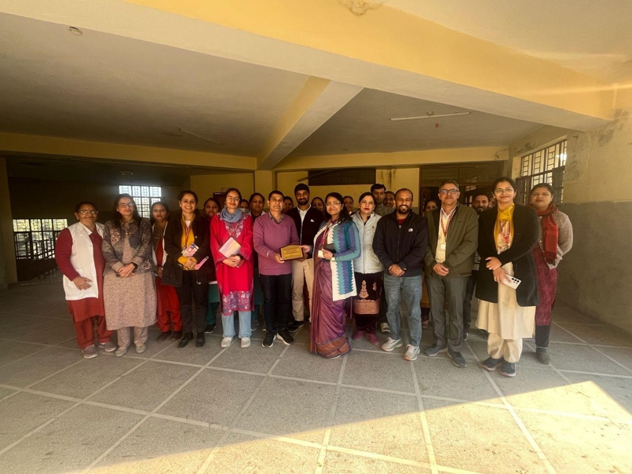

HICC, AIIMS Bilaspur successfully conducted a workshop on “Prevention of Surgical Site Infections (SSI)” with the motto: “Prevent SSI, Protect Every Patient.” on 13th August, 2026
The workshop witnessed enthusiastic participation from approximately 100 delegates from various clinical and support specialties.
The programme focused on a practical, multidisciplinary approach to SSI prevention, including:
🔹 Hands-on demonstration of Hand Hygiene
🔹 Pre-operative, intraoperative and postoperative preventive measures
🔹 Clinical interaction and case-based discussions with faculty from Surgery, Orthopaedics, Anaesthesiology and Obstetrics & Gynaecology
🔹 Role of Antimicrobial Stewardship Programme (AMSP) in preventing SSI and promoting judicious antimicrobial use
🔹 Importance of Central Sterile Supply Department (CSSD) practices in infection prevention and patient safety

The workshop highlighted that prevention of SSI is a shared responsibility, requiring coordinated efforts across clinical departments, microbiology, nursing, CSSD, AMSP and the entire healthcare team.

Prevent SSI. Protect Every Patient.

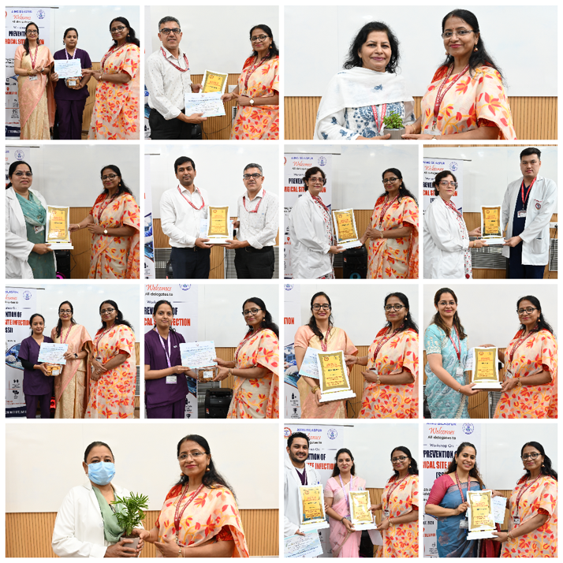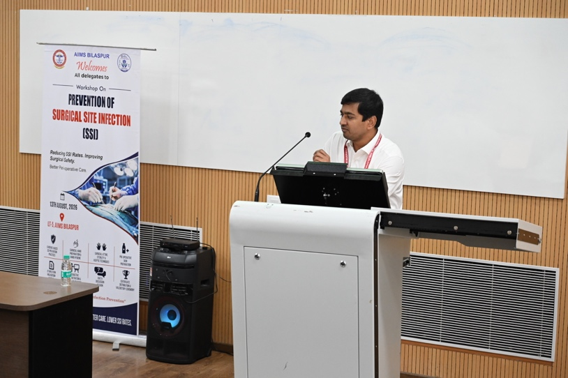
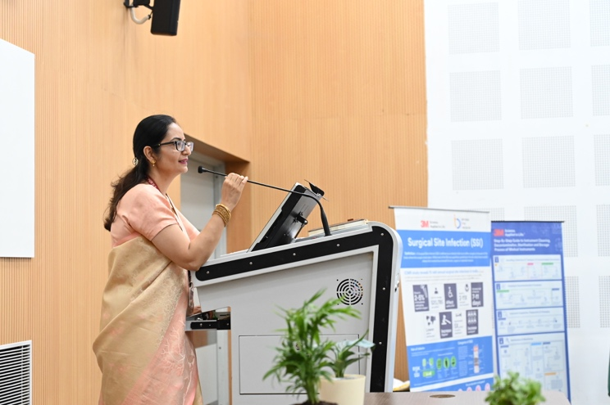
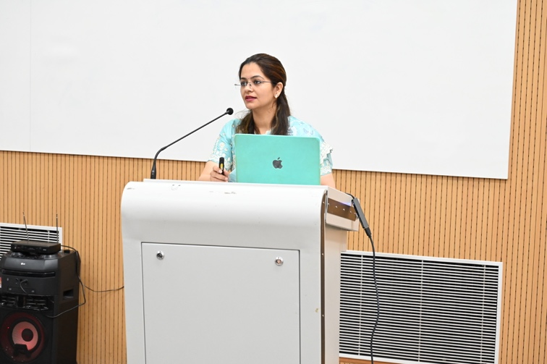
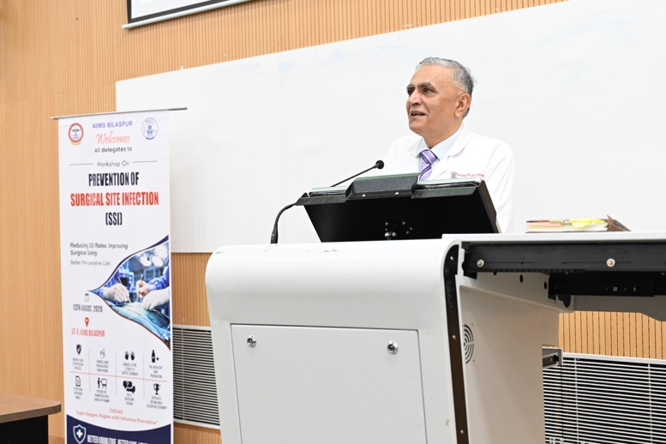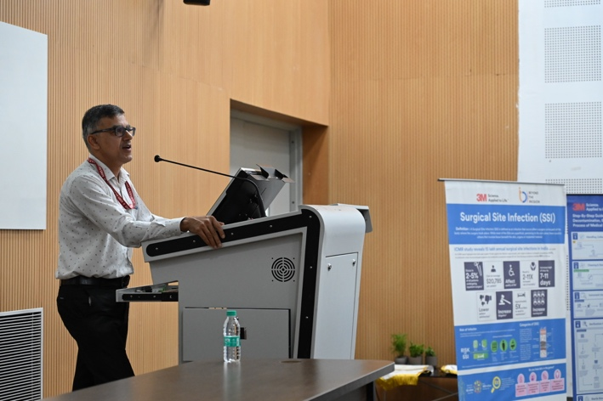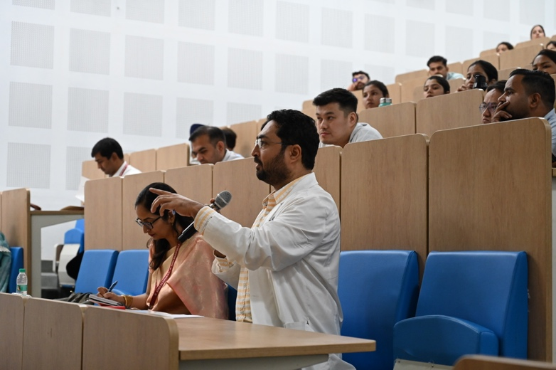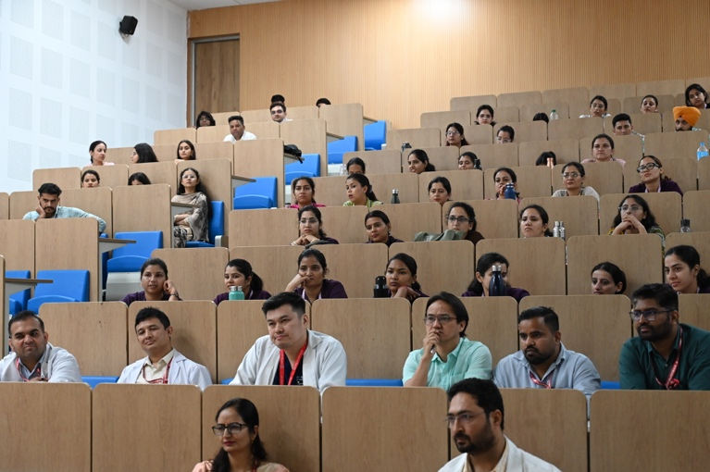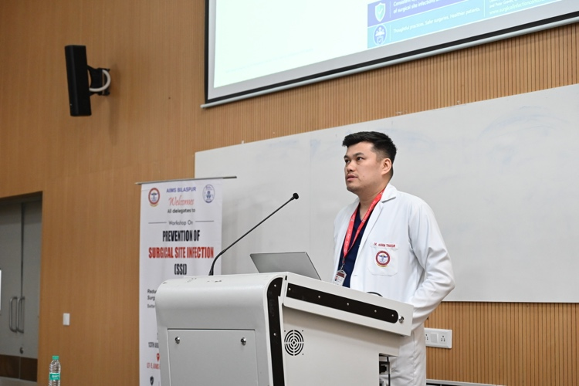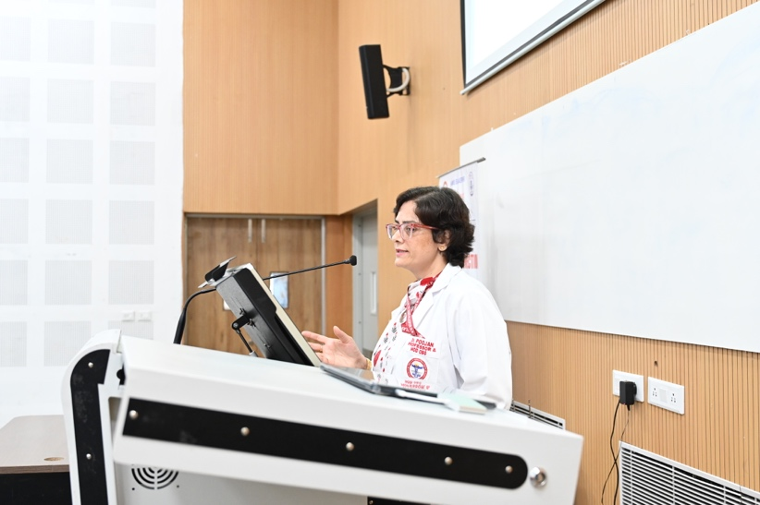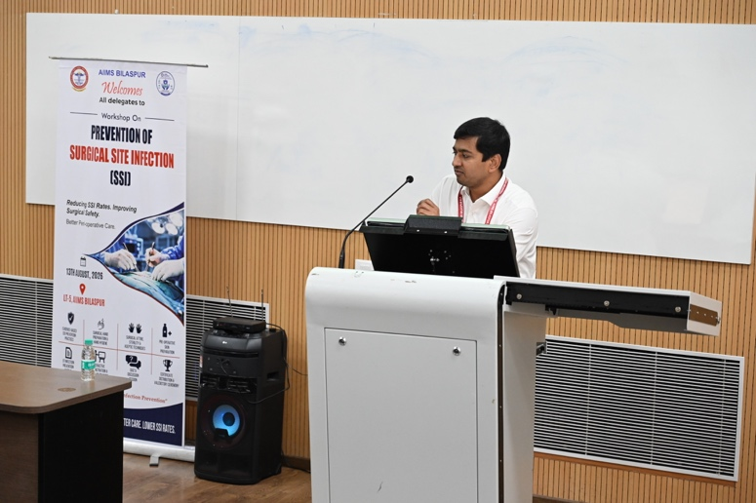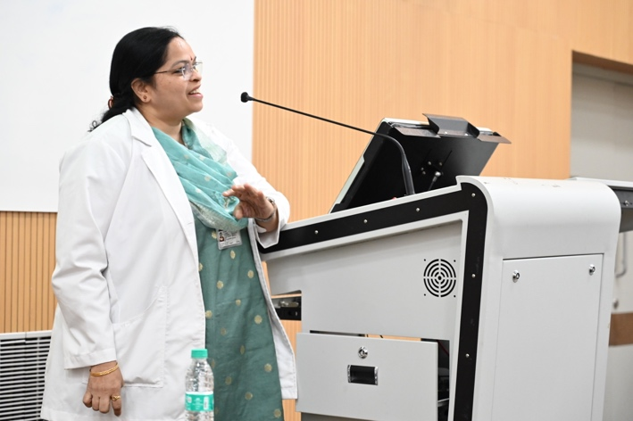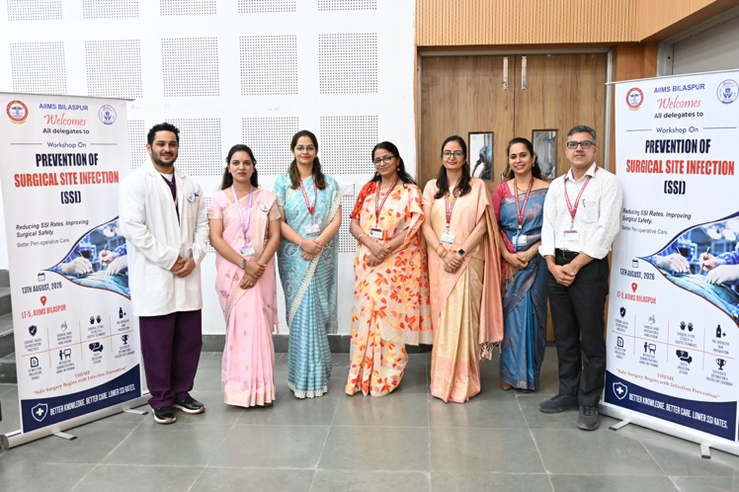

The Department of Microbiology at AIIMS Bilaspur, observed World Hand Hygiene Day with a series of targeted activities aimed at promoting effective hand hygiene practices and strengthening patient safety on 4th and 5th May, 2026. The program aligned with the global theme “Action Saves Lives” advocated by the World Health Organization.

A key highlight was the “Hand Hygiene on the Go” campaign conducted across wards and outpatient departments, reaching over 100 healthcare workers, including doctors, nursing officers, sanitary attendants, and hospital attendants. Participants were trained using the Glow Germ gel technique, which demonstrated commonly missed areas during hand hygiene under UV light, enhancing awareness and compliance.

MBBS students actively contributed through a nukkad natak (street play) that emphasized the importance of hand hygiene among healthcare workers, patients, attendants, and the general public. A dance performance further reinforced the message through creative expression.

The event also featured a reel-making competition with enthusiastic participation and a slogan-writing competition for faculty, both focusing on innovative communication of hand hygiene practices. A quiz competition with cash prizes was conducted for sanitary and hospital attendants to strengthen their role in infection prevention. Healthcare workers collectively took a hand hygiene pledge, committing to consistent practice and promoting awareness among peers and patients. The program concluded with a valedictory session graced by the Executive Director, who appreciated the department’s efforts in fostering a culture of safety.

The initiative effectively highlighted that hand hygiene is a simple yet powerful measure to prevent infections and save lives, reinforcing sustained commitment across all levels of healthcare delivery.
